- Assume that you want to balance a (real) ball on a (real) saddle.
Why is this hard?
Reply: Because a saddle point is any location where all gradients of a function vanish but which is neither a global nor a local minimum. It is one of the important reason to induces gradients vanishing. Therefore, it is hard to find a balance point to keep the ball balance on a saddle.
Can you exploit this effect also for optimization algorithms?
Reply: Introducing ReLU activation function. For instance, assume that we want to minimize the function f(x)=tanh(x)f(x)=tanh(x) and we happen to get started at x=4. As we can see, the gradient of f is close to nil. More specifically, f′(x) =1−tanh²(x) and thus f′(4)=0.0013. Consequently, optimization will get stuck for a long time before we make progress.
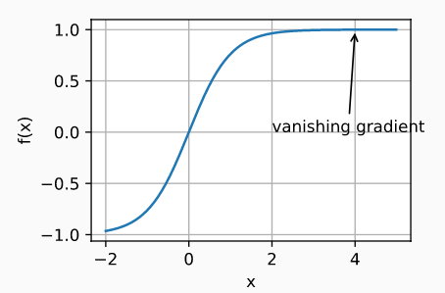
- What changes when we perform SGD with momentum? What happens when we use minibatch SGD with momentum?
Reply: If we perform SGD with momentum, the learning process can accelerate to continue to move at the saddle point or escape from some local optimal regions.
When we use the momentum optimization algorithm, the problem of large swings in the update range of the mini-batch SGD optimization algorithm can be solved, and make the network convergence faster at the same time.

